Unit 4 Assignment: Logistic Regression Model
Burn Study Logistic Regression Model
Thais da Silva Jimenez Brabham
University of Maryland Global Campus
DATA 645 Machine Learning
Dr. Marwan Omar
September 9th, 2025

Burn Study Logistic Regression Model
1. Introduction
1.1. Objective and Rationale
The goal of this logistic regression model is to understand the predictability of true and false positives regarding the survival and death rate of victims of burn injuries. In order to do so, a data exploration analysis was done, including preprocessing steps, and logistic regression using python codes.
1.2. Problem Domain
According to the World Health Organization article about Burns, in 2023, the number of deaths by burn can reach up to 180 thousand cases per year, mainly affecting lower-income countries. This shows the relevance of studies that investigate the factors that mostly influence these deaths in order to prevent these cases continuing to happen, aside from the prevention measures that should be widely spread to the populations.
2. Analysis
2.1. Data
The dataset was obtained from GitHub, Burn Code Sheet, and it contains 9 columns and 1000 rows. There are integer and float types of variables, which are listed below with their number, description, possible results, and name. This table was taken from the GitHub website.
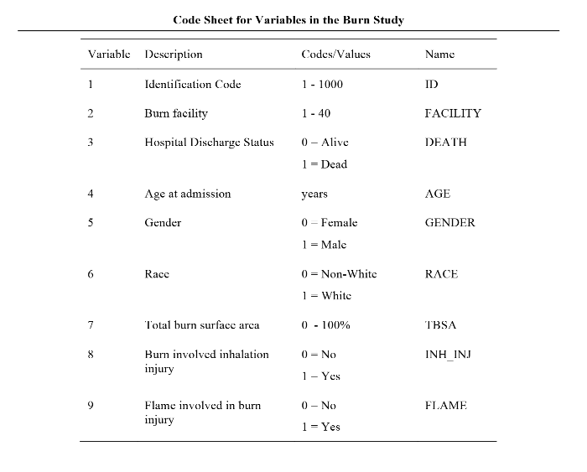
2.2. Exploratory Analysis
The exploratory analysis was conducted by running Python codes to understand the dataset structure and creating visualizations that helped clarify the relationships between variables. First, the info and describe codes were used to show the data types, quantity of variables, and entries in the dataset, and the summary statistics with the central tendency from each variable, presenting the count, mean, standard deviation, min, 25%, 50%, 75% and max. The dispersion shows, as an example, that the variance of age was 607, the standard deviation of age was 24, and the range of age was 89. The images can be found attached to the appendix.
Secondly, the visualizations created investigated more deeply some relevant variables and if there were meaningful relationships between them. To understand TBSA (total burn surface area), age, death, inhalation injury, and the relation between them it was used histograms, boxplot, and heatmap, respectively, as seem below.
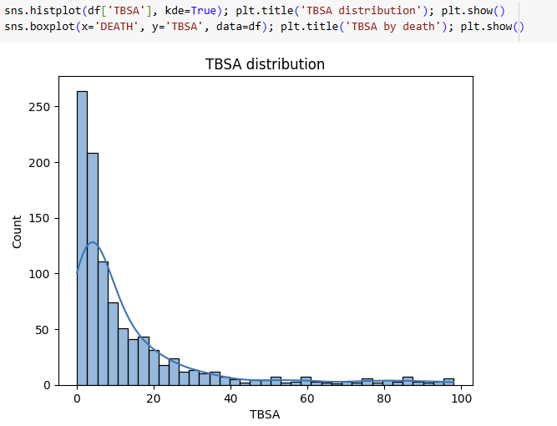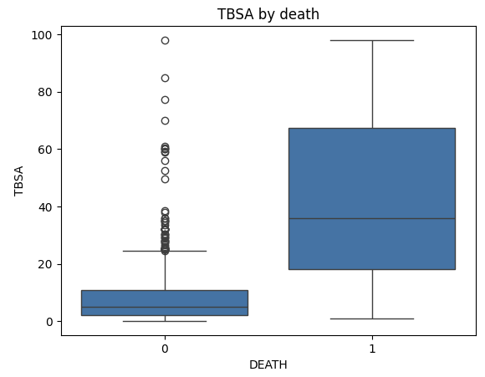
The histogram presents the total burn surface area distribution, showing that the majority of the cases had less than 10% of surface burnt. While the boxplot relates the total burn surface area with death, showing that most of the death cases had around 20-65% of surface burnt, which brings the interpretation that all the deaths had a considerable amount of the body burnt, meaning that this could had been decisive for the outcome.
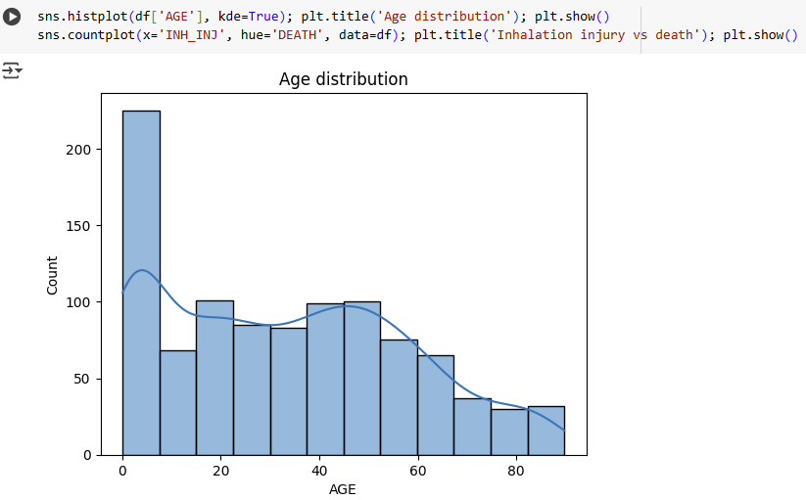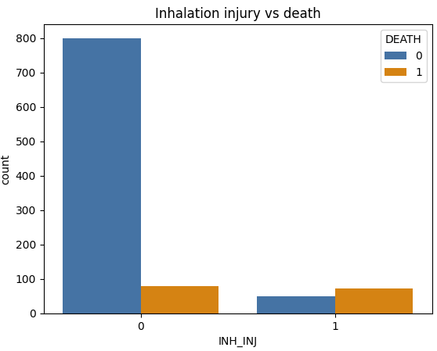
The age distribution histogram shows that the majority of the burn cases happened to people younger than ten years old, and the rest was fairly distributed until the age of 65, when the number of cases drastically declined. And the visualization presenting the relation between inhalation injury and death shows that the number of people who had inhalation injury and the people who did not had it, had both a very close number of deaths, meaning that the inhalation does not seem to be a major reason for the deaths.
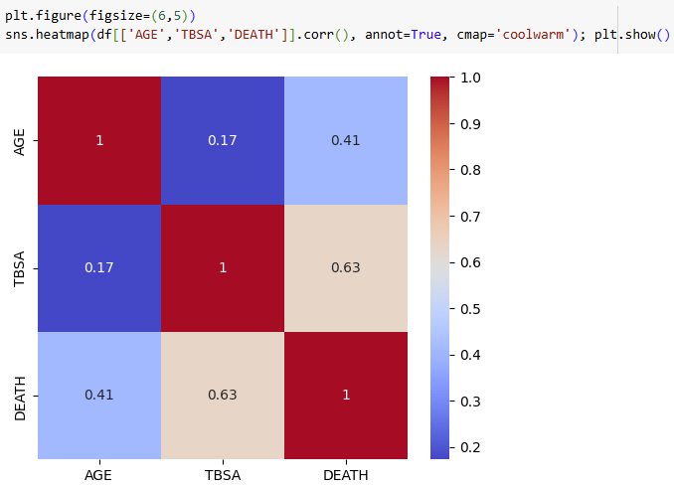
The heatmap presents the relationship between age, total burn surface area, and death, where the closer to red would be the variables that are mostly related. In this case, the strongest relationship was between total burn surface area and death, as also presented on a previous boxplot visualization. And there is some relation between age and death as well.
2.3. Preprocessing
The preprocessing stage was composed of Data Cleaning, Data Reduction, and Data Transformation. On the data cleaning stage, it was discovered with the df.isnull().sum() code that there were no missing values in this dataset since it outputs all variables with zero results (picture in the appendix). And to verify if there was any repeated data, it was used the duplicated code to make sure there was no noisy data, and the result came back as zero results as well. Therefore, no data cleaning was necessary in this case.
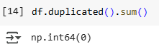
On the data reduction stage, some variables were grouped into their mean values in order to understand some of the possible trends from this dataset. The mean age showed that both genders had an average of 33 years old. The average age of death for women was 0.16, and for men it was 0.14, while for non-white people it was 0.13, and for white people it was 0.16. The average death rate was the highest among the 70+ age group, while the age group that had a high number of total burn surface area was between 50-70 years old. And the codes outputs also presented that the male, 70+ age group, had more cases of flame-burnt and inhalation injury as well. Lastly, the crosstab function showed that there were more cases of male deaths, although the proportion was smaller when compared to the total number of male and female cases. And the age group with the largest number of deaths was the 50-70 and 70+ group; however, the 70+ group had a much smaller number of total cases compared to the rest.
Lastly, in the data transformation stage, the ages were grouped between <30, 30-50, 50-70, and 70+ in order to facilitate the data analysis and the possibility of finding meaningful trends on the dataset. The image from the outcome is also attached to the appendix.
2.4. Algorithm Intuition
With the goal to find the probability of death based on the dataset presented, the logistic function was used to create a sigmoid visualization that presents the relation between probability and z (linear score), where the more negative the z more likely would be a case of survival from burn injury, while the higher the z also the higher the possibility of death from burnt. And if the probability is 0.5 or higher, it predicts death, and on the other hand, if it is lower than 0.5, then it predicts survival, as can be seen in the visualization below:
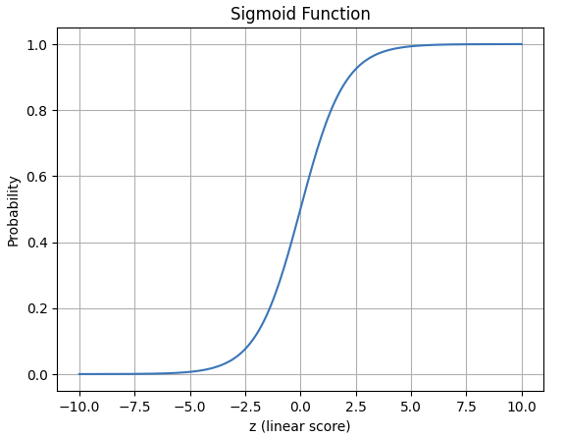
2.5. Model Fitting
The model fitting stage was necessary to verify if the training model was adequate to be used further without any missing values or data that could provide incorrect results for the analysis. As seem below, the outcome presented that there were no inconsistencies on the dataset and it was good to be used for a model.
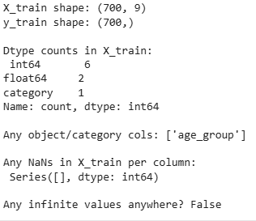
3. Result
3.1. Output
After running the python code to check the accuracy of the prediction of the survival after burn injury using the code below, it was detected that the accuracy on the tested data was of 0.98, which is a high probability of correct prediction.
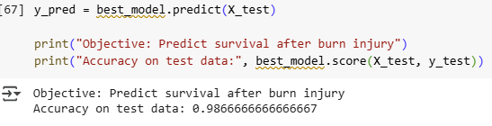
3.2. Model Properties
The model properties step showed how strong the prediction for each variable was, and how much each variable could be affected by the odds of survival. The variable with the strongest coefficient was the TBSA (total burned surface area), meaning that this variable presented a very high chance of being a positive predictor. And its odds ratio presented that each time the TBSA increased, the odds would also increase by 1.582959e+01 times. And the second strongest variable was Age with a 2.25 coefficient and 9.484940e+00 odds ratio.
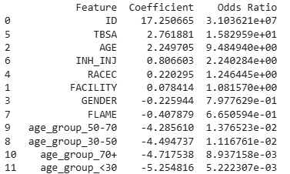
3.3. Evaluation
The evaluation investigated the classification report, the confusion matrix, and the ROC curve. The classification report presented that the logistic regression model was 99% accurate, meaning that the evaluation is trustworthy, especially because the false negatives were mostly false positives, which is more acceptable than if it were the other way around.
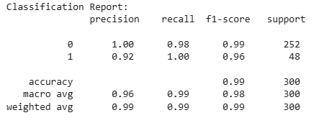
The confusion matrix compares the actual and predicted results, confirming that the majority were true positives, followed by true negatives.
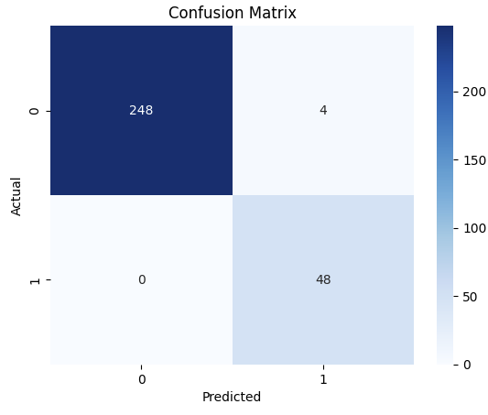
Lastly, the ROC curve also confirms that the model can almost always predict results correctly since the AUC line goes around the graph meeting both ends from the true and false positive predictions.
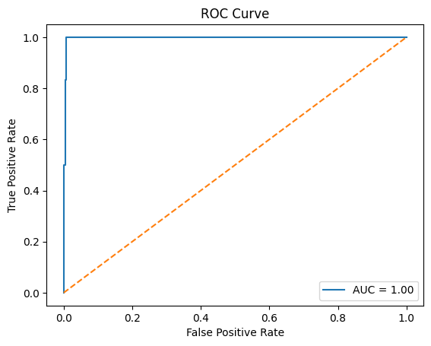
3.4. Diagnostics
The diagnostics check from this analysis presented the errors compared to the predicted probability to show what kind of error this dataset’s logistic regression presented. As seem below, the residuals are aligned in both ends, which can mean that the results are essentially perfect when it comes to the prediction. Or that could mean that one of the variables is influencing these diagnostic results, needing to be investigated further.
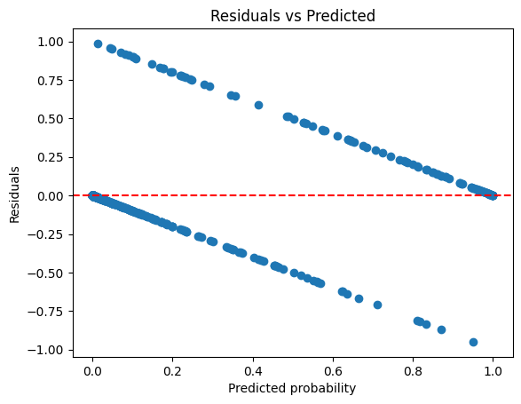

4. Conclusion
This Burn Study Logistic Regression Model concluded that the variables that mostly influence the prediction of survival or death from burn injury are the TBSA (total burn surface area) and the age, both strong predictors with high coefficient and odds rate. Therefore, the higher the TBSA higher the chances of death, as well as the older the person who suffered the burn, the higher the possibilities of death.
The logistic regression evaluation and diagnostic showed that the predictions presented, based on the dataset tested, have a 99% chance of true and false positives, being a highly trustworthy model to be used further to predict survivals and deaths cases.
The dataset analysis has room for improvement since it also presented limitations. As presented in the diagnostic, there is the possibility that either the prediction is almost 100% certain to be correct, or a variable could be interfering in the results, making it more trustworthy than it should be. Therefore, for future reference, it would be positive to do a second investigation into the exploratory analysis fase to reassure these results.
5. References
Code Sheet for Variables in the Burn Study. By GitHub. https://github.com/lbraglia/aplore3/blob/master/rawdata/BURN/BURN_Code_Sheet.pdf
Burns. 2023. By World Health Organization. https://www.who.int/news-room/fact-sheets/detail/burns
Burn Incident Fact Sheet. By American Burn Association. https://ameriburn.org/resources/burn-incidence-fact-sheet/

6. Appendix
